Web Application: Adaptive Workout Plan

The Adaptive Workout Plan is a user-friendly web application designed to deliver personalized workout plans based on the users’ preferences. This single-page application will provide users with three upright rectangles to choose from. Users first click their preferred workout type, then proceed to click the desired workout intensity, and finally, the application displays their choices along with a download button, restart button and contact information to a personal trainer. By pressing the download button, users can download a pdf of their customized workout plan, or by pressing the restart button they will be directed back to the start of the application.
To make this application I have chosen to use HTML, TypeScript, CSS and Tailwind CSS for Frontend. Django and SQLite for Backend.
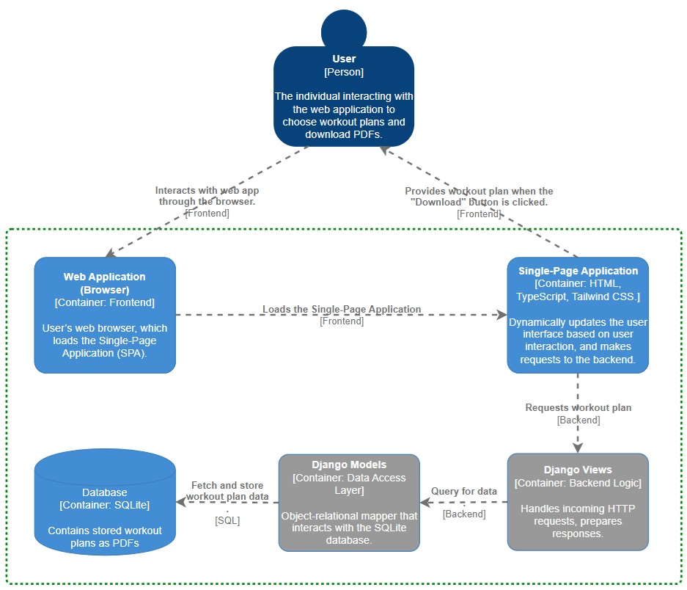
Several dynamic aspects enhance the user experience in this application, the most obvious one is clicking the workout pictures and difficulties proceeding dynamically through the application. A more subtle dynamic aspect is that the text of the personal trainer will change based on the selected options. The last dynamic aspect of the application is when the user clicks the download button to receive the workout plan based on their selections.

